FIREBIRD
1. Install Firebird 2.5 first, using the default selection. <Next> until finish.
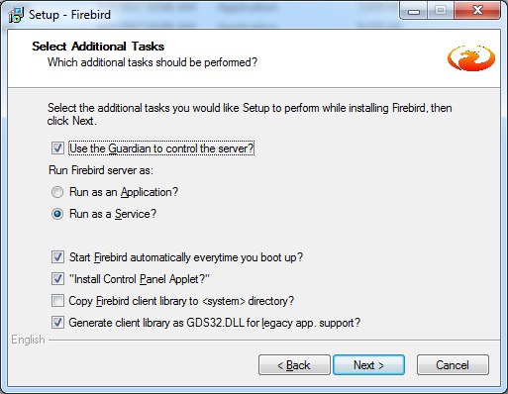
2. Don't start the services.
3. Continue to install Firebird 3.0, below message will prompt out, click <No> to continue installation.
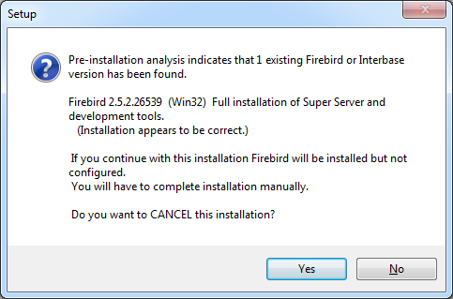
4. Using the default selection, <Next> until finish.
SERVICES
5. Manual create services for Firebird 3.0 using command prompt (cmd). Change the directory to where the Firebird 3.0 is install and then key in below command.
> instsvc i -name "firebird3"
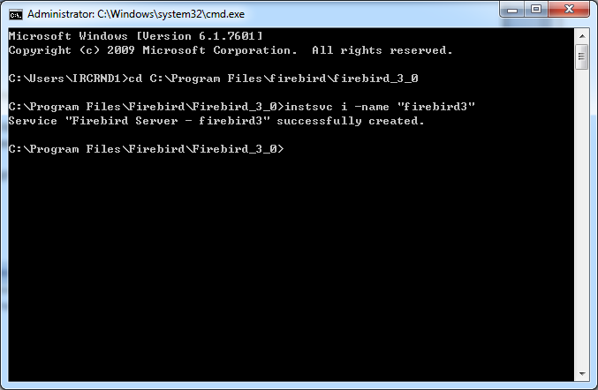
6. Open Services window. There should have 3 firebird services appear as below. PLEASE MAKE SURE ALL STARTUP TYPE IS SET "AUTOMATIC"
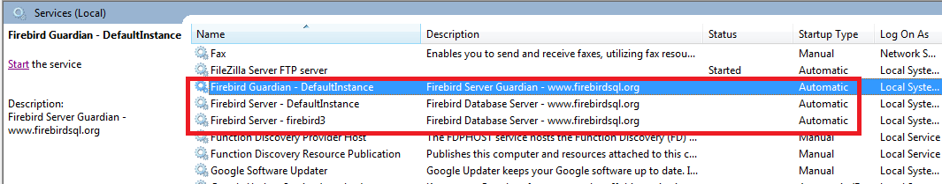

7. Using notepad to open "services" file in C:\Windows\System32\drivers\etc
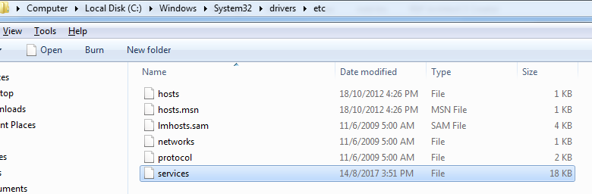
8. Define the port to the firebird services.
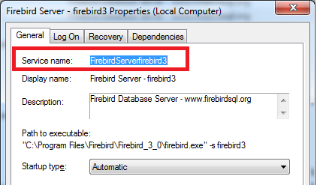
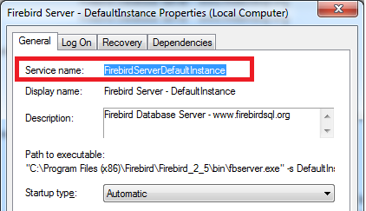
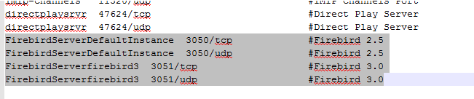

9. Go to Firebird 2.5 path and open "firebird.conf" file, and change the RemoteServiceName to the name set in services file (Item #8) and port 3050
(REMEMBER TO REMOVE #)
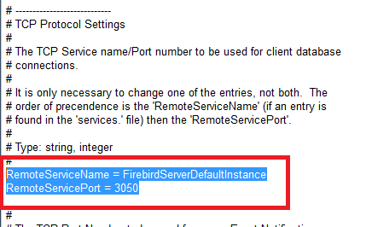
10. Go to Firebird 3.0 path and open "firebird.conf" file, and change the RemoteServiceName to the name set in services file (Item #8) and port 3051
(REMEMBER TO REMOVE #)
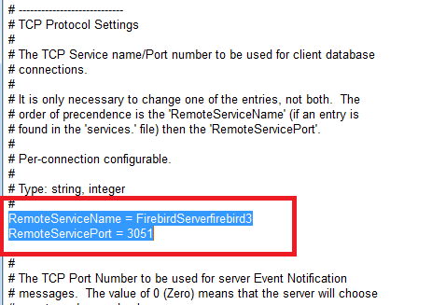

11. Restart PC.
SQL ACCOUNTING
12. Open SQL Accounting, click "..." button
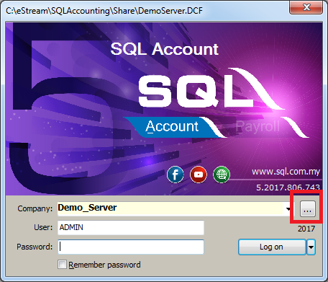
13. Select "Back to Database Group".
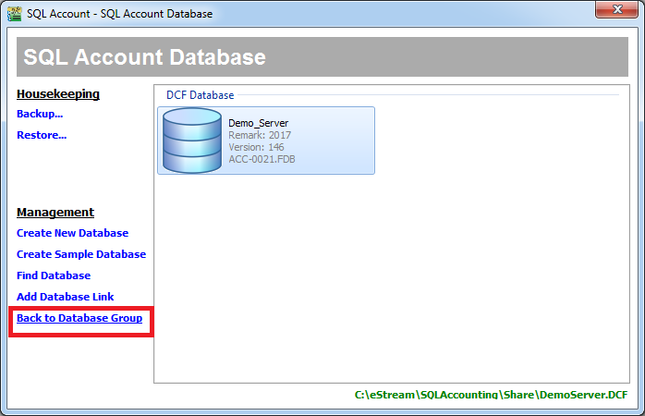
14. Go to SQL Account Database properties.
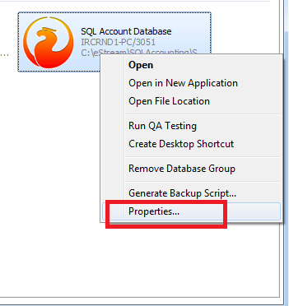
15. Add "/3051" after the server name and click on "Test Connection", server version should point to version 3.0
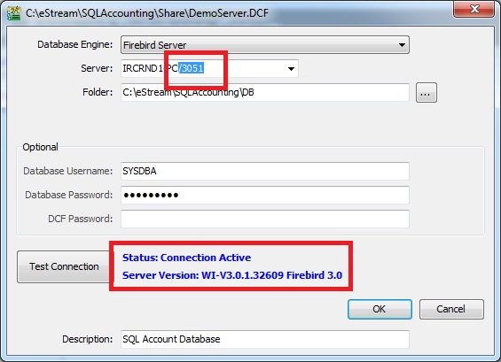
16. Check on Cougar application, it should be open as normal.

