**********************
* Readme QubePos.txt *
**********************
* Background.bmp/jpg = W1024 x L768
* FloorN.bmp/jpg (N=1-9) = W871 x L589
* Customer.bmp/jpg = W141 x L60
* Dealer.bmp/jpg = W149 x L63
* Welcome.bmp/jpg = W383 x L95
*
***************
* Mail Server *
***************
* Yahoo
-----
Outgoing Mail Server (SMTP)
Host Name : smtp.mail.yahoo.com
Require Authentication : Tick
Server Port : 465
Time Out (Sec) : 10
Method : SSLv3
* Gmail
-----
Outgoing Mail Server (SMTP)
Host Name : smtp.gmail.com
Require Authentication : Tick
Server Port : 465
Time Out (Sec) : 10
Method : SSLv3
*
***************
* Time Server *
***************
1. Change the server type to NTP.
Registry Key: HKEY_LOCAL_MACHINE\SYSTEM\CurrentControlSet\Services\W32Time\Parameters\Type
Change value data to: NTP

2. Set announce flags.
Registry Key:
HKEY_LOCAL_MACHINE\SYSTEM\CurrentControlSet\Services\W32Time\Config\AnnounceFlags
Change value data to: 5

3. Enable NTP server
Registry Key:
HKEY_LOCAL_MACHINE\SYSTEM\CurrentControlSet\Services\W32Time\TimeProviders\NtpServer
Change value data to: 1.

4. Specify the time sources.
Registry Key:
HKEY_LOCAL_MACHINE\SYSTEM\CurrentControlSet\Services\W32Time\Parameters
Change value data to: <peerlist>
<peerlist> is a list of space-delimited NTP peers from which time can be received. If DNS names are used, you must append ‘,0×1’ to each DNS name. Alternatively, a list of IP addresses can be specified.

5. Select poll interval.
Registry Key:
HKEY_LOCAL_MACHINE\SYSTEM\CurrentControlSet\Services\W32Time\TimeProviders\NtpClient\SpecialPollInterval
Change value data to: <period>
<period> is the time in seconds between each poll. Microsoft recommends a value of 900, which equates to a polling frequency of once every 15 minutes.

6. Set the time correction settings.
These settings specify a time frame to validate time stamps received from an external reference. Only if the received timestamp falls between these registry settings will they be accepted. It provides a facility to reject timestamps that are too far away from the hosts system time. Microsoft recommends a setting of 1 hour (3600) or 30 minutes (1800).
Registry Key:
HKEY_LOCAL_MACHINE\SYSTEM\CurrentControlSet\Services\W32Time\Config\MaxPosPhaseCorrection
Change value data to: <seconds>
Where <seconds> is the maximum positive offset of the received time stamp from the system time.

Registry Key:
HKEY_LOCAL_MACHINE\SYSTEM\CurrentControlSet\Services\W32Time\Config\MaxNegPhaseCorrection
Change value data to: <seconds>
Where <seconds> is the maximum negative offset of the received time stamp from the system time.
7. Restart the windows time service.
Stop and restart the Windows Time Service using the ‘net stop’ and ‘net start’ commands:
net stop w32time && net start w32time
Synchronizing a Windows Workgroup

Applies to:
Microsoft Windows XP.
Microsoft Windows Vista.
Microsoft Windows 7.

=====================
12.126.0.0 2012-04-01
=====================
1) New QubePos.exe
2) Training Mode
3) Direct Login to Q-Service
4) Grouping Filter

=====================
12.126.1.0 2012-04-26
=====================
1) Option to Print Order No Details
2) Option To Print Body Header
3) Add Change Table
4) Add Price Change
5) Add All TOV Data

=====================
12.126.2.0 2012-05-03
=====================
1) Add PgUp & PgDw For All Memo Log
2) Day End Closing Send Report By Email
3) Q-Service Option Without Tax
4) Add Condiment
5) Add Auto Program Upgrade
6) Add Receipt Barcode No.
7) Add Receipt Priner
- Citizen CT-S310II
- SurePrint SP90
8) Add Cash Drawer
- SureDrawer
9) If Pay By Credit Card Option To Print
- Masking Of Card Holder Name & Card No.
- Signature
10) Option To Print
- [Qyts]
- [Items]
11) Option To Not Print The Change If Zero

=====================
12.127.0.0 2012-06-04
=====================
* alter table POS_SALESDTL add SDTL_STK_LABEL D_CHAR1 DEFAULT 'F'
* alter table POS_COUNTER add CTR_LABELNO D_INT DEFAULT 0
1) Label Printer Support BIXOLON SLP-D220

=====================
12.128.0.0 2012-06-05
=====================
* alter table POS_SALES add SALES_LABELNO D_INT DEFAULT 0
1) Label Running No.

=====================
12.129.0.0 2012-06-09
=====================
* alter table POS_SALESDTL add SDTL_CONDIMENT D_LRGMEMO
1) Option To Reset Label No. After EOD

=====================
12.131.1.0 2012-06-18
=====================
1) Smart Lock Command Changed
2) alter table FNB_TABLE add F_XY D_CODE12 DEFAULT '0,0'
3) Item Option To View
a) Stock Code
b) Barcode
4) Add To 60 Tables
5) Floor Mapping
6) No Enter Pax No., Receipt No Print Pax No.
7) TOC Setting
8) Option View Language Button
9) If QubeTime.exe Not Found, Module Not Found
10) No Table, No Table No. Button
11) Payment With Fixed Value
12) Open Member
13) Sales Remark

=====================
12.131.2.0 2012-07-14
=====================
1) Database Training Didn't Back To Normal - Solved
2) EOS & EOD Open Drawer
3) Auto Prompt Cash Management With Option
4) After Day End Closing Block Transaction
5) Show Shift Report By No Shift
6) Report With Non Change Payment

=====================
12.131.3.0 2012-07-18
=====================
1) After All Shift End Closing Block Transaction
2) Item Dicount Can Clear
3) Tax Can After Discount or Before Discount

=====================
12.131.4.0 2012-07-18
=====================
1) No Sales With Remark (Option)
2) Print Discountable Amount On Receipt (option)
3) Print Taxable Amount On Receipt (option)
4) Sales Remarks
5) Time Attendance In Login Screen
6) All Disc
7) Auto Close After Swipe Credit Card
8) Enable Discount 2 (Option)

=====================
12.131.5.0 2012-07-20
=====================
1) Security Level :
a) Item/All Discount
b) Sales Remark
c) Open Discount
2) Report Show Pax No In Normal Sales Only
3) View Shif Report With Not EOS Yet
4) Selection Of Discount
- Item Discount
- Subtotal Discount
5) Item Sorting
- Code
- Description
- Seq
6) Payment Sorting
- Code
- Description
- Seq
7) After Open Member Call All Discount (Option)
8) Credit Card Dialog
- Auto Open
- Auto Close
9) Item Void After Hold (Security Level)
- VOIDHL
10) Add Report
- Bill Summary Report
- Bill Audit Report
- Table Performance Report
11) After Open Price Call Edit Description

=====================
12.131.6.0 2012-07-24
=====================
1) Modify Reports
- Bill Summary Report
- Bill Audit Report
2) Fixed Un-EOS Report
3) Clear Database With Password
- Clear

=====================
12.131.7.0 2012-07-28
=====================
1) Check Kick Drawer By Payment
2) Define Number Of Receipt Print
3) No Sale & Re-Print Receipt On Table Screen
4) Re-Print Receipt By Daily or Periodic
5) Can Do Shift End Closing With Outstanding Bill
6) Customer Meal Count
7) Support SCL010 Mifare Card Reader

=====================
12.131.8.0 2012-08-11
=====================
1) Dept Move To Top With Max 15 REcord

=====================
12.131.9.0 2012-08-13
=====================
1) Hourly Sales By SKU Report
2) Hourly Report View With 12/24 Hour Format
3) Trans Void On Table Screen

=====================
12.131.9.0 2012-08-21
=====================
1) Item Kitchen Message

======================
12.131.10.0 2012-08-25
======================
1) New Item Kitchen Message
2) Open Kitchen Message

======================
12.131.11.0 2012-09-03
======================
1) Kitchen Message Log
2) Restart KPS
3) Undo Function

======================
12.131.12.0 2012-09-05
======================
1) Day End Closing Show Pending EOS & EOD
2) Show Version in Table & Manager Setup Screen
3) Restart KPS Move To Manager Setup Screen 2
4) Reset Master Table If All Sub Table Deleted
5) Next Day After EOD (Optional)

======================
12.132.0.0 2012-09-08
======================
1) Add Fields
- POS_CLOSEINFO
- CI_REPORT
- FNB_EOS
- F_REPORT
2) Save EOS & EOD Reports Into The Field Above
3) Send EOD Reports with attachment By Email
4) Re-Print EOS & EOD Reports

======================
12.132.1.0 2012-09-14
======================
1) Show Both No. In POS Operation Screen
- Customer No.
- Member No.

======================
12.135.0.0 2012-09-24
======================
1) Add Fields
- POS_PAYSUMM
- PYSUMM_OPERID_APPROVE
- PYSUMM_REMARK3
- PYSUMM_REMARK4
- PYSUMM_REMARK5
- PYSUMM_REMARK6
2) Record Trans Void Info
3) Record Change Table Info
4) Combine Table
5) Auto Quit After 30 Sec Of Change Screen
6) To Define Main Cashier Or Not

======================
12.136.0.0 2012-10-02
======================
1) Split Table
- Add Fields
- POS_SALESDTL
- SDTL_SPLIT0
- SDTL_SPLIT1

======================
12.136.1.0 2012-10-15
======================
1) Split Table (Fixed)

======================
12.136.2.0 2012-10-18
======================
1) Backup
2) Transfer Table
3) Auto Log Off For
- Payment
- Hold
- Bill

======================
12.136.3.0 2012-10-30
======================
1) Select Agent
2) FOC
3) Report
- FOC Detail Report
- Agent Sales Report

======================
12.136.4.0 2012-11-05
======================
1) House Bon
2) Not Allow Partial Payment (Fixed)
3) Report
- House Bon Report

======================
12.136.5.0 2012-11-29
======================
1) Receipt Add Agent
2) Split Table From Others Terminal (Fixed)
3) Optional To multi Language

======================
12.136.6.0 2012-11-29
======================
1) Cashier Report Show CID
2) Item Sales Report Access Denied (Fixed)

======================
12.136.7.0 2012-12-11
======================
1) Transfer/Split Table With Item Voided Total Not Tally (Fixed)

======================
12.136.8.0 2012-12-20
======================
1) Reporting Button On Table Screen

======================
12.136.9.0 2013-01-07
======================
1) Printing Amount Error (Fixed)
- Cash Management
- No Sale

======================
12.136.10.0 2013-01-09
======================
1) Auto Connect DB When In Setting
2) Table Button
- Square
- Round
- Round Edge
3) Receipt With Signature
- Add House Bon (Option)
4) Disable User Setup
5) Quick Service Option To Hold Bill
6) Option To Record No Sale Count
7) Send EOS Report Via Email (New)
8) Resend EOS/EOD Report Via Email
9) Support Gmail/Yahoo Email

=======================
XE12.137.0.0 2013-02-27
=======================
1) Sorting View
- Condiment Group
- Condiment List
- Grouping
2) Option To Run
- Time Attendance
- DCS
3) House Bon Option To Include/Exclude Sales
4) Multi Barcode With Expiry Date
5) Customer Display Option To show 'I'M'
6) Masking Credit Card Info In DB
7) Resend Item To Kitchen Printer
8) Item Cancel With Reason
9) Item Cancel Report

=======================
XE12.137.1.0 2013-04-01
=======================
1) Department View Full Width

=======================
XE12.137.2.0 2013-04-10
=======================
1) Button Coloring
- Grouping
- Stock
- Payment
2) Floor Maping
- Table Can set Different Size and pattern
3) Option To Print Shift Report
4) Re-confirm To Do EOD
5) Able Resize Content Font
6) Option To Hide Quit Button At Login Screen

=======================
XE12.138.0.0 2013-05-18
=======================
1) 2nd SvrTsPos
2) Clear Sales

=======================
XE12.138.1.0 2013-06-05
=======================
1) Group Sub-Link

=======================
XE12.138.2.0 2013-06-10
=======================
1) Prompt Business Date At Startup (Option)

=======================
XE12.138.3.0 2013-06-24
=======================
1) Login User Name Masking
2) Block Payment If No Payment Record
3) Re-allocate 2x5 Button
4) Option To Double/Triple Character
5) Option To Print Receipt
6) Bill/Hold Will Send To Kitchen Printer
7) Condiment Load Faster
8) Condiment Qty Same With Master when press + / -
9) Better Big Resolution Viewing
10) Lock Table

=======================
XE12.138.4.0 2013-06-29
=======================
1) Lock Table Access Level
2) Press Table 1 Sec Pop Menu
3) Change Closing Date
4) Move Left/Right

=======================
XE12.138.5.0 2013-07-16
=======================
1) Set Menu
2) Pull Down

=======================
XE12.138.6.0 2013-08-20
=======================
1) Dual Customer Display
- 2 x 20 Char Display
- Item Sales Viewing
- Video Viewing (Wmv,avi)
- Picture Viewing (bmp,jpg)
- Signage Viewing
2) Reset Database
- All Store & All Terminal
3) New Printing For Set Menu

=======================
XE12.140.0.0 2013-09-20
=======================
1) Support KDS
2) Q-Service
- Takw Away
- Dine In
3) Open Member (OpenMemb.ini)
- With String Formatting
- Member Group With Discount Selected
4) Table With Item Link Max 5
5) Reset Database Connection
- Password '88888888.'

=======================
XE12.141.0.0 2013-09-21
=======================
1) Report Dine-In & Take Away

=======================
XE12.141.1.0 2013-09-25
=======================
1) Q-Service Enable/Disable
2) If Database Connection Failed, system will Log Off
3) Clear Sales History By Date Range
4) Sales Reports Exclude Condiment Qty
- Group, Department, Sub-Dept,
Catogary, Item
5) KP Didn't print for Queue Code With Alphabetic (Fixed)

=======================
XE12.141.2.0 2013-10-19
=======================
1) Baby-Q POS Version
2) Show Default Price If Different Price Shift
3) Condiment & Menu Item Didn't Show On Customer Display
4) Double Click Logo To Edit Item Color
5) Item & Payment Add Scroll Bar
6) Auto prompt Open Price If Price 0

=======================
XE12.142.0.0 2013-11-19
=======================
1) Q-FNB POS Version
2) Sales Mode
- Take Away
- Dine In
- Delivery
3) Plu Wih Price/Weight
4) Auto Show Item If SubLink Department Record = 1
5) Include Condiment Sales
- Group
- Department
- Sub-Department
- Category
6) Condiment Sales Report
7) Refund Item With Reason

=======================
XE12.142.1.0 2013-11-27
=======================
1) Shift Price Reset To Default When Log Off
2) Bug Fixed - Coloring Dept

=======================
XE12.142.2.0 2013-12-03
=======================
1) Receipt format With Unit Price Show Decimal For Qty (Fixed)
2) Item With Price Length 12/13

=======================
XE12.142.3.0 2014-01-02
=======================
1) Encryption
2) Open Price With Tax (Solved)

=======================
XE12.142.4.0 2014-01-04
=======================
1) Taxable Amount Description
- Tax 2, Tax 3, Tax 4

=======================
XE12.142.5.0 2014-01-23
=======================
1) After EOS Paid Out Print Last Record (Solved)

=======================
XE12.143.0.0 2014-03-06
=======================
1) Prepaid Card
- PaidCard.ini
- NecoList.txt
- SCL.exe
- OTP.dll
2) Fix Batch File
- db\FixWsPos.bat
- db\FixTsPos.bat
- db\FixSvrTsPos.bat
3) Power Off Button At Login Screen
4) Option To Reset Table If Receipt Not Found
5) Support Firebird 2.5
6) Item Agent

=======================
XE12.143.1.0 2014-03-26
=======================
1) Call Business Date When start-up DB Not Connected (Solved)
2) Change Screen Print & OK Big Button
3) Agent Item Sales Report
- Summary
- By Trans
- By Item
4) Support Customer Card Format

=======================
XE12.143.2.0 2014-04-16
=======================
1) Support Tax Symbol
2) E-mail EOS/EOD Report Support PDF
3) Select Customer No Clear (Fixed)
4) New Item Mapping Style
a) 1 x 4
b) 1 x 5
c) 1 x 6
d) 2 x 5

=======================
XE12.143.3.0 2014-04-21
=======================
1) Menu Item Able Mapping Position
2) Sub Menu With Wallpaper

=======================
XE12.143.4.0 2014-05-15
=======================
1) 'Change Screen' Move Close Button Position
2) Item Didn't View When Menu Entry (Solved)

=======================
XE12.143.5.0 2014-05-27
=======================
1) Support Tax Symbol
- Malaysia
- Singapore
2) EOS/EOD/CONS Agent Item Sales Report
- Summary
- By Trans
- By Item
3) Open Price Item will prompt Enter Price For Condiment (Fixed)
4) Mapping.ini Changed
[CDM_Key]
Condiment_Group_Sort -> CDM_Group_Sort
Condiment_List_Sort -> CDM_List_Sort
5) Report With Group Sales
- Shift Sales Report
- Terminal Sales Report
- Transaction Sales Report

=======================
XE12.143.6.0 2014-07-25
=======================
1) Cashier Max Discount
2) Cashiet Alert Amount
3) Support EDC-MagIC

=======================
XE12.144.0.0 2014-07-28
=======================
1) Compulsory Enter Cash Declaration
2) Sales Remark Up to 5 Records
- Print On Top Position Of Receipt
3) Auto Prompt Sales Remark If Exceed Amount

=======================
XE12.144.1.0 2014-08-06
=======================
1) Fix Pax No, Table No
- Transaction Report
- Terminal Report
2) Grid Function Key changed

=======================
XE12.145.0.0 2014-08-12
=======================
1) Table With Card ID
2) Table Show Time
- Seat Time
- Elapsed Time

=======================
XE12.147.0.0 2014-09-20
=======================
1) Add GST Summary On Receipt
- Standard-Rated
- Zero-Rated
- Exempted
- Out-of-Scope
2) Qty # Format
3) Dual Display Add
- Bill No
- Table No
4) User Can Define Logo File

=======================
XE12.147.1.0 2014-10-10
=======================
1) Control Enter customer Card By Swipe

=======================
XE12.147.2.0 2014-11-07
=======================
1) GST Summary Caption (Fixed)
2) Receipt View Then Print
3) Taxable Amt With Discount (Fixed)
4) Option To Print Stock Code On Receipt
5) Setting
- Option To Change System Date Time
- Option To Change Business Date
6) Option To Show Gross Sales With Add In Tax

=======================
XE12.147.3.0 2014-11-17
=======================
1) Next Day After EOD
- Option Ask Confirmation.
2) GST Summary Report

=======================
XE12.147.4.0 2014-12-27
=======================
1) Backup TsPos.fdb at ..\Log\EOD\TsPos??.fdb When Doing EOD
2) Add On Setting For Business Start Time

=======================
XE12.148.0.0 2015-01-13
=======================
1) Update GBAK Version
2) Add Customer Address

=======================
XE12.148.1.0 2015-03-03
=======================
1) Start GST Not Allow Subtotal Disc
2) Receipt Don't Show Taxable Amount For Add In If Show GST Summary
3) Support SCL011 Mifare Reader
4) Optional Print/Prompt Customer Address With Exceed Amount
5) Credit Card Dialog Will Turn Off When Not Set Auto Open Credit Card Dialog
6) Bug Fixed For Auto Log Off When No Table Exixts For Q-Service
7) Print Sales Mode On Receipt/Bill/Order List
8) Q-Service Asking Sales Mode
9) Bug Fixed If User Code Is Alphabetic Press NS Error

=======================
XE12.148.2.0 2015-03-18
=======================
1) System Setup - Character - Page 3 Not Appear If Press Receipt First
2) Support SCL011G Mifare Reader
3) Zero Price Tax Will Not Calculate When Change To Price Item.
4) Item Cancel Report Show After Hold [H] or After Bill [B] Status
5) Transaction Void Report

=======================
XE12.148.3.0 2015-03-23
=======================
1) Able To Preset
- Receipt No
- X-Reading No
- Z-Reading No
- Label No

=======================
XE12.148.4.0 2015-03-25
=======================
1) Tax On Tax In Taxable Amount
2) Setup Password Changeable

=======================
XE12.148.5.0 2015-03-29
=======================
1) Fixed Un-Lock Table
2) No Sales Receipt Print Date Time Error When No Record Count - Fixed

======================
XE12.148.6.0 2015-04-27
======================
1) Price Auto Updating By Date
- If Using BackEnd XE3.229.0.0
2) Thousand Separator - Fixed
3) Tax Link If Service Charge On Add In Item
4) Auto Power Off
5) PBB Debit Card No Name Appear Invalid Data - Fixed
6) Tax Exempt Can Select At Backend
- If Using BackEnd XE3.229.0.0
7) Block Item If No Output Tax When GST Running
8) Add GST Adjustment Value In Report
9) Round Adj Fixed (Add In)

======================
XE12.148.7.0 2015-05-12
======================
1) Change GST Adjustment To Amt Adjustment
2) Report - Serv Chrg Without Take Away

======================
XE12.148.8.0 2015-05-12
======================
1) Add Amt Adjustment In GST Summary Report

======================
XE12.148.9.0 2015-05-25
======================
1) Customer By Credit/Sales Limit
2) Add CLOUD 3700 Mifare Reader
3) PaidCard.ini
[Setting]
Timer_Delay=250
4) XZ And Receipt Backup Copy In Log\000000\
5) TsPos.fdb EOD Backup Copy In Log\EOD\
6) Check Customer Credit By
- Date Log
- Closing
7) Item Void Reason Change'|' To '#'

=======================
XE12.148.10.0 2015-05-28
=======================
1) Credit/Sales Limit Print On Receipt

=======================
XE12.148.11.0 2015-06-14
=======================
1) Print Receipt No Format
- Store/Terminal/Receipt No
2) Data Don't Put '|'
3) Add Tax Exempt Symbol
4) Set Hold Screen By Seconds
5) Auto DB Disconnect
6) Show IP and DB On Login Screen
7) Show Last Change Amount
8) Fixed Credit Limit Balance

=======================
XE12.148.12.0 2015-07-28
=======================
1) Not Allow Void Sub-Item
- Option
2) Round Tax Amount
- Option
If Want To Recalculate The Non Round Tax Amount :-
- SQL For Inclusive Tax
eg. update pos_sales set
sales_taxamt = (sales_netsales-SALES_ROUND_ADJ)*6/106,
sales_tax2 = (sales_netsales-SALES_ROUND_ADJ)*6/106,
sales_taxableamt2 = (sales_netsales-SALES_ROUND_ADJ)*100/106,
sales_taxable2ctot = (sales_netsales-SALES_ROUND_ADJ)*100/106,
sales_gstamt_s = (sales_netsales-SALES_ROUND_ADJ)*100/106,
sales_gsttax_s = (sales_netsales-SALES_ROUND_ADJ)*6/106
where sales_ctrno = '056' and sales_closedate = '05/31/2015'
3) Customer Excess Credit Limit (Fixed)
4) Print Customer Name (Optional)

=======================
XE12.148.13.0 2015-08-18
=======================
1) Customer Credit Amount Didn't Add Back When Doing Transaction void.
Must Using Refund.
- Fixed

=======================
XE12.148.14.0 2016-02-12
=======================
1) Key In Stock Code With Multi Price Level Price Show 0 - Fixed
2) Pos Integration - Atria
3) Support MYEG

=======================
XE12.148.15.0 2016-05-03
=======================
1) Full Tax Invoice

=======================
XE12.148.16.0 2016-06-20
=======================
1) Print Average Per Pax On Receipt
2) Auto Prompt Select Table

=======================
XE12.148.17.0 2016-07-23
=======================
1) Adjust Screen Report Font Size If column Width Different
2) Email SSL Setting Updated
- Port 465 / 587

=======================
XE12.148.18.0 2016-08-10
=======================
1) New Tax System
--- ------- -------- -----------
Tax Desc Tax Link Calculation
--- ------- -------- -----------
T1 Serv10% T2 Add On
T2 Gst6% Standard Rated Add In

=======================
XE12.148.19.0 2016-08-13
=======================
1) Training Mode By User

=======================
XE12.148.20.0 2016-08-25
=======================
1) On-Line Stock

=======================
XE12.148.21.0 2016-09-27
=======================
1) 3 Layers Item Selection
2) Show Sales Item Detail
3) Show Stock Balance (Optional)
4) Print Receipt No. On Top (Optional)
5) User Login List
6) Alert CID SalesMon.ini

=======================
XE12.148.22.0 2016-09-30
=======================
1) Print Item Agent On Receipt (Optional)

=======================
XE12.148.23.0 2016-10-02
=======================
1) Pos Integration - Dpulze
- Accounting Link Module

=======================
XE12.148.24.0 2016-10-13
=======================
1) Option To Print EOS/EOD Closing Report On Screen or Printer
2) Table Over Time Change Color
3) Print Combine Item

=======================
XE12.148.25.0 2016-10-20
=======================
1) Option To Print Order Header
2) Show Business Date On Login (Optional)
3) Show Work Shift On Login (Optional)
- No Need EOS
4) Show Order Time At Detail Screen
5) Not Share Check Tracking and Settle Payment (Optional)

=======================
XE12.148.25.1 2016-10-31
=======================
1) Item Void No Function After Hold Fixed

=======================
XE12.148.26.0 2016-11-22
=======================
1) Arrangement Key Call Select Agent - SF4#12345678
2) After Select Agent Call Payment (Optional)
3) After Hold Call Sales Remark (Optional)
4) Print Table Barcode (Optional) - T10
5) Print Receipt Barcode (Optional) - T01/0101/12345678
6) Select Receipt List Show Table No
7) Compulsory Agent
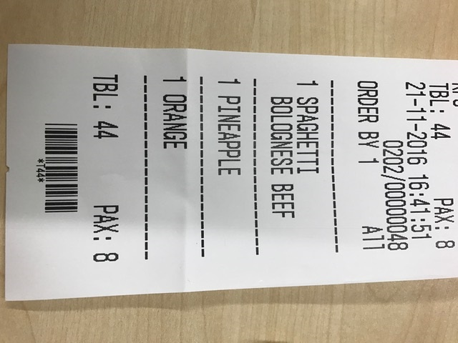
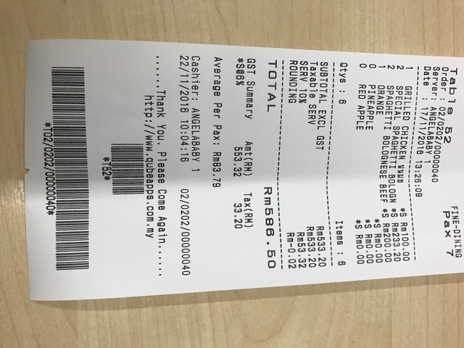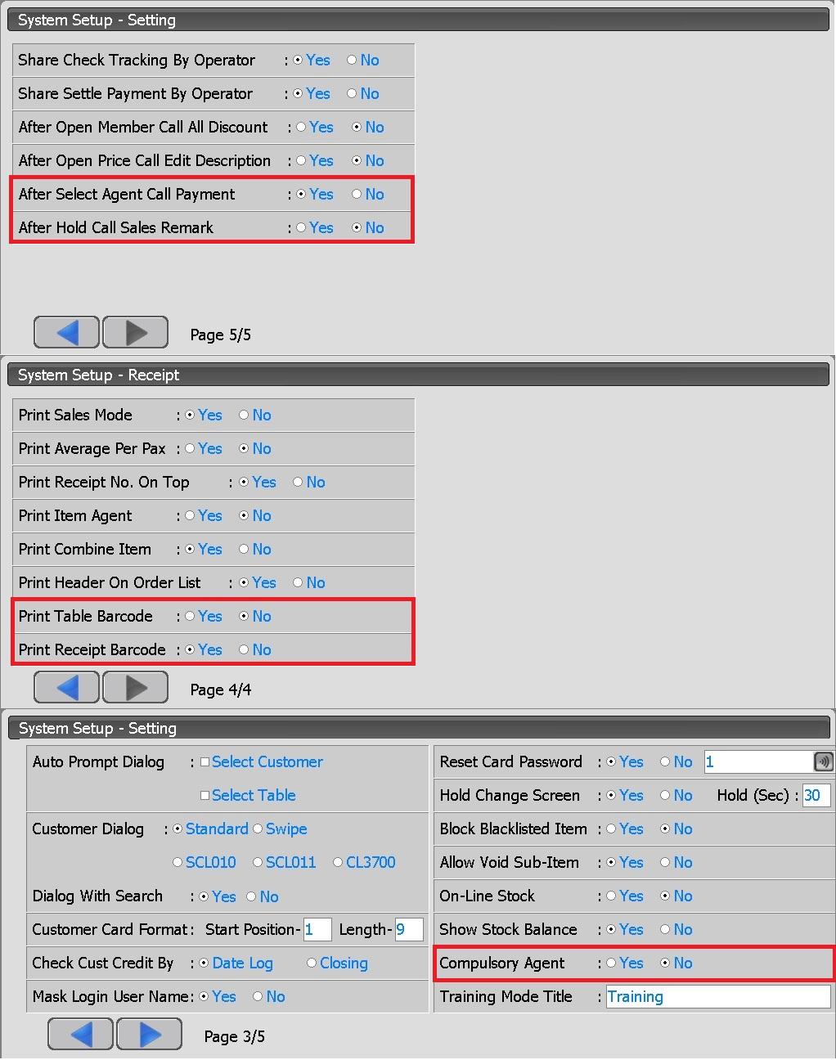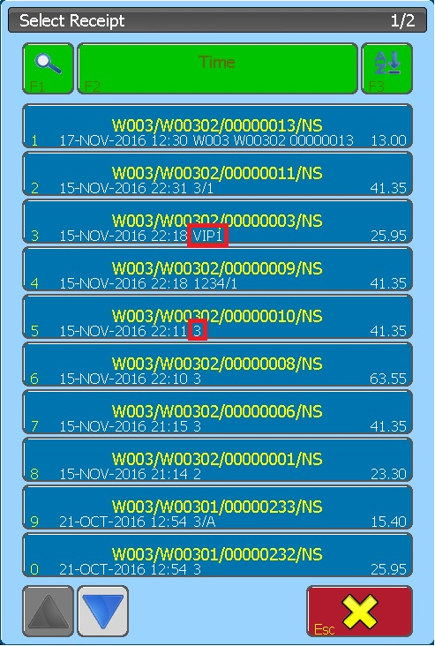

=======================
XE12.148.27.0 2016-12-02
=======================
1) Trim New Table Code
2) No Print Item Agent For Condiment
3) No Print Default Price For sub Item
4) Label Printer Support Argox OS-214
5) Option Send To Kitchen
- Change Table
- Combine Table
- Item Void
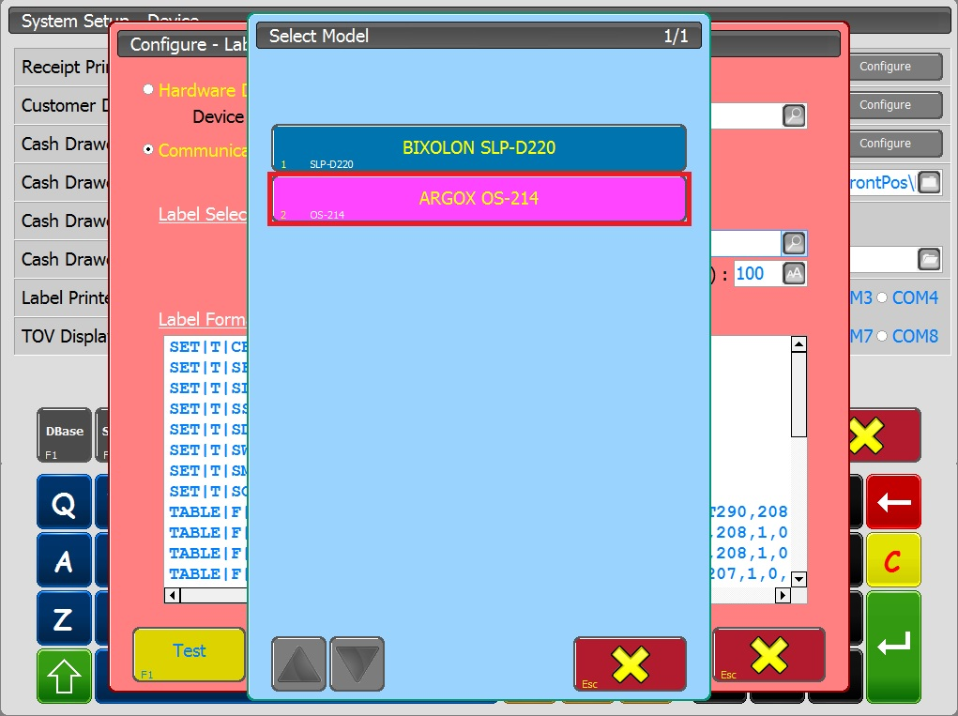
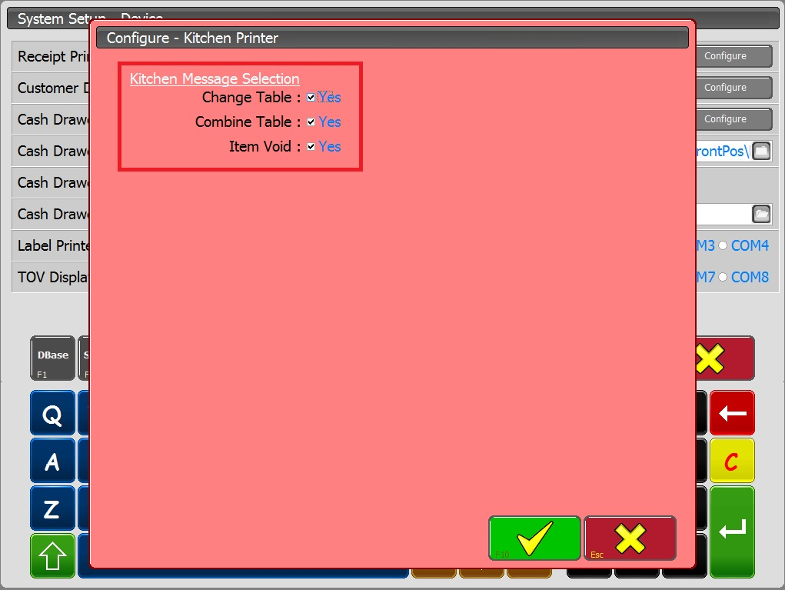

=======================
XE12.148.28.0 2017-01-09
=======================
1) EOD Update Transaction Void Amount Into POS_CLOSEINFO
2) Fix Condiment Column

=======================
XE12.148.29.0 2017-02-02
=======================
1) Optional Select Agent With Search.
2) Optional Allow To Add Open Condiment Item.
3) Condiment Item With Color.
- Double Click Title
